What SNE does that it preserves neighbourhood and distance in a neighbourhood.

Below given a example where we are converting from 2-D to 1-D, where data in 2-D is present in form of square, at corner of squares, and therefore neighbours of each point are

N(x1) = { x2, x4 }

N(x2) = { x1, x3 }

N(x3) = { x2, x4 }

N(x4) = { x1, x3 },

Now we plot them in 1-D, we start with x1, and for this we are able to plot x2(left of x1) and x4(right of x1).

Now for x2 also we are able to preserve dist for x1(right to x2) and x3(left to x2).

Now for x3 we are able to preserve distance for x2, but we can’t plot x4 that can preserve dist.

And same for x4.

Therefore there are some problems(like square, cube, hypercube) for which it is impossible to preserve distance in all the neighbourhoods. This problem is known as crowding problem.

This crowding problem is resolved by t-SNE.

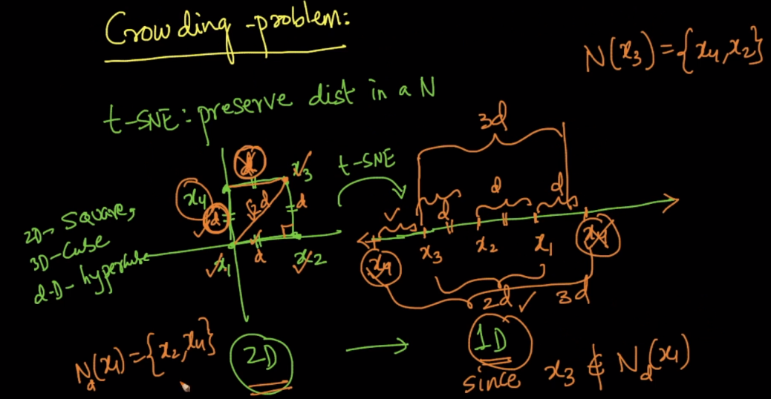

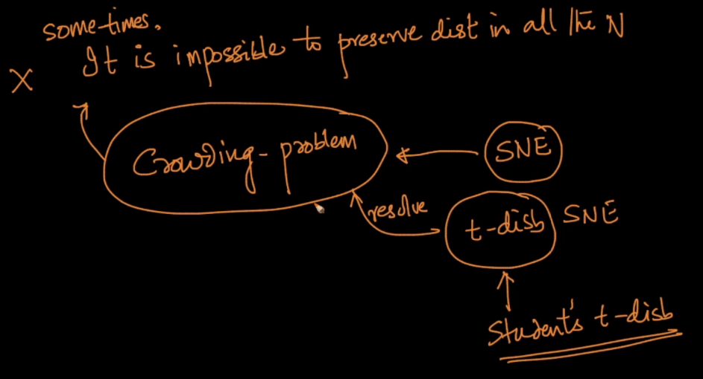

There can be a question that we can plot x2 and x4 over each other, that means in overlapping manner, but if we do this it will not preserve neighbourhood as after plotting like this in 1-D we have wrong neighbourhood for x2 = {x1, x3, x4} and x4 = {x1, x2, x3}, And since the ultimate aim for SNE to preserve neighbourhood and therefore we can’t do this.

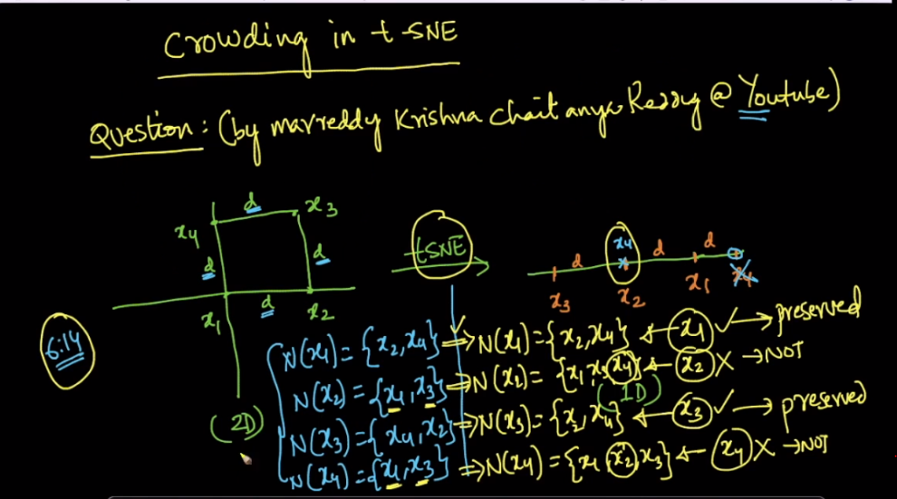

Also, t-SNE is used for visualization, which means points which are different from other must be placed at different places while visualizing but here even though x2 and x3 are different points but we are getting them at same place.

